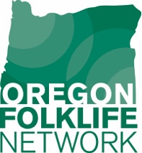

CULTURE FEST
Staff Evaluation

Thank you for participating in Culture Fest! Please complete the questionnaire below. Your responses will help us evaluate the program and plan effectively for future programs.

- What was the name of the program in which you participated?

- What was your role?
Venue staff
Presenting organization staff
Volunteer
Folklorist
Intern
Student
Administrator What organization?
Other

- What went well?

- What could have gone better?

- Do you think the publicity/PR was effective? If not, what could have been done differently?

- Did the program increase visitorship? By how much?

- Did the program diversify visitorship? How (age, ethnicity, other)?

- What would make for a better program for next time?

- What kinds of cultural arts programs would you like to see here in the future?

- Do you know of any local folk and traditional artists with whom we or Oregon Folklife Network should be in touch? Please list names, traditional art form, and contact information if possible:

